

Foundations of Programming

Assignment No. : 06
PROBLEM STATEMENT:Write a C function to compute the factorial of a number with and without recursion.

OBJECTIVE:

To demonstrate two different approaches for calculating the factorial of a number: iterative (non-recursive) and recursive, showcasing the versatility of problem-solving methods in programming.

THEORY:
- Explain the difference between the iterative and recursive approaches to calculating the factorial of a number.
- What is the base case in the recursive function for computing factorials, and why is it necessary?
- How does the program handle invalid input, such as negative numbers, and why is this important?
PLATFORM: Linux

Algorithm:
- Start
- Accept a number 𝑛
- Calculate 𝑛! using recursion
- Calculate 𝑛! using iteration
- Return both results
- Stop

Code:
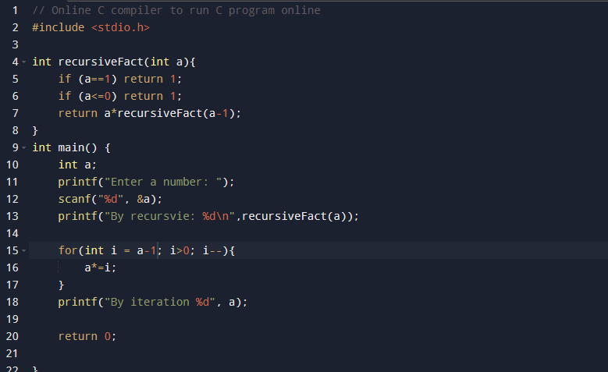

INPUT: 5!
OUTPUT: 120 120
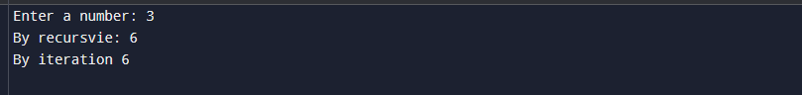
CONCLUSION: Thus, we have successfully executed factorial of a number with and without recursion.

FAQs:
1. What is the purpose of calculating factorial in programming?
2. What is the difference between recursive and non-recursive (iterative) methods?

